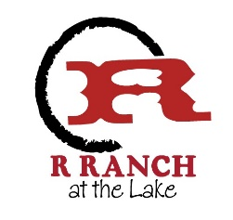

December 1st, 2019

Dear Owners,
It has come to our attention that there was a discrepancy in the annual assessment packet outlining the site to site fee as $600.00, while the October quarterly board meeting ratified the fee increase to $500.
This was an oversight on the board and management’s behalf, while we did discuss increasing site to site to $600.00 to expedite the funding of the campground upgrades, it was never formally ratified.
We learned from this experience that while we spent a great deal of time working to revise R-Ranch Rules & Regulations for the Campground, Cabins, and Stables, we must be more mindful of proper documentation and board protocol.
We appreciate owner feedback and partnership as we continue to rebuild R-Ranch.
For those whom have already sent in a site to site lottery check in the amount of $600, should your name be chosen as a winner in the lottery on January 19th, 2019 we will hold your check and allow 7 business days to replace it with a check for $500.00 or you may choose to apply the $100 difference to your account.
Should you have any additional questions or concerns please email the board at bod@rranch.info.

Sincerely,

Sue Riley
Secretary
R-Ranch Board of Directors

